- Write in a standard form
  - 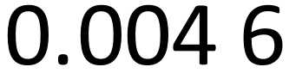
  - 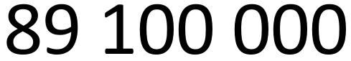
- Write as a number
  - 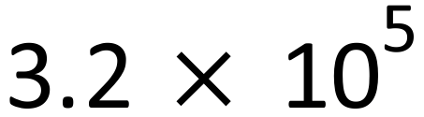
  - 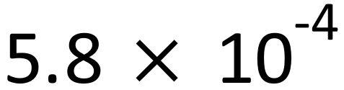

- Give your answers in standard form

- 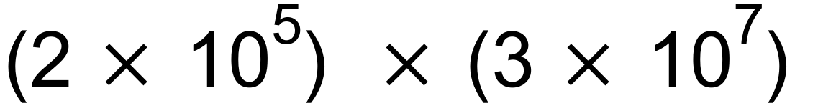
- 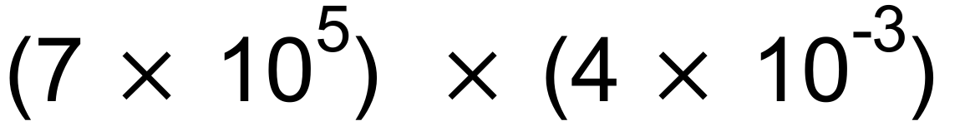
- 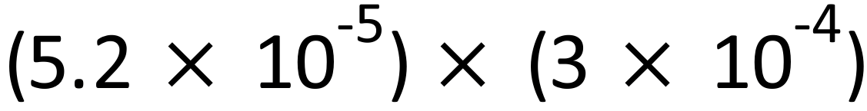
- 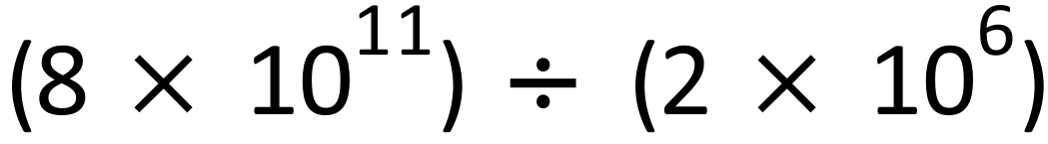
- 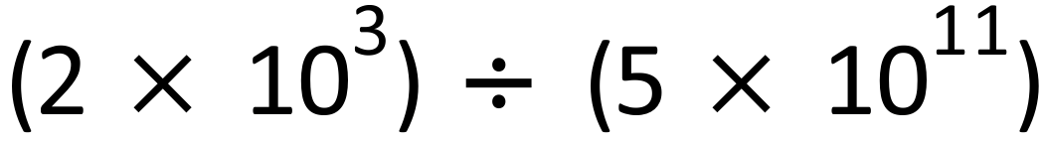
- 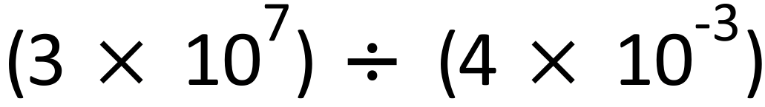
- 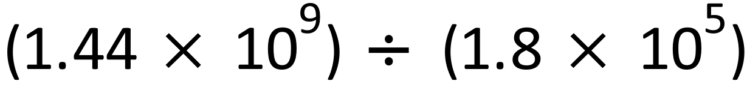
- 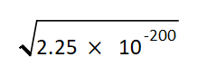

- Give your answers in standard form
- The perimeter of a square region is $7.28×{10}^{12}$ m.
(give your answers in standard form and to 2s.f.)
  - Find the area.
  - Find the length of diagonal

